Senior Frontend Developer – React & Next.js
Pune, India

About the role
We are seeking an experienced Senior Software Engineer – Frontend (React / Next.js) to join our growing engineering team in Pune, working on a healthcare-focused SaaS product used by organisations to deliver critical services to communities.
This is a senior frontend engineering role for someone who takes ownership of technical delivery, works effectively through ambiguity, and builds high-quality user-facing applications that are maintainable, performant, accessible, and reliable.
You will take ownership of important frontend features and workflows from design through to delivery, contribute to technical decisions, and help improve the quality and maintainability of the platform over time. Alongside hands-on development, you will also play an important role in supporting good engineering practices and raising standards across the team.
You’ll work closely with backend engineers, QA, and product colleagues in a collaborative environment that values pragmatic thinking, clean implementation, and sustainable delivery.

Our Development Culture
We work in a collaborative Agile environment, delivering incrementally and focusing on building software that is maintainable, reliable, and fit for real-world use.
We value pragmatic engineering over unnecessary complexity. That means writing clear, sustainable code, making sound technical decisions, and working closely across engineering, QA, and product to deliver high-quality outcomes.
We are also continuing to evolve how we build software through modern engineering practices and tooling. Senior engineers are expected to use good judgement, contribute positively to team standards, and help raise the overall quality and effectiveness of the engineering team over time.

Key responsibilities
- Design, build, and maintain high-quality frontend applications using React, Next.js, and TypeScript
- Take ownership of frontend features and workflows from technical design through to delivery and ongoing improvement
- Contribute to and help shape implementation decisions, frontend patterns, and engineering best practices to support a maintainable and reliable platform
- Work closely with backend engineers, QA, and product colleagues to deliver well-designed, well-tested product features
- Build user-facing experiences that are performant, accessible, responsive, and maintainable
- Investigate, troubleshoot, and resolve complex technical issues, with a focus on identifying root causes and implementing sustainable fixes
- Support the quality of the codebase through code reviews, testing, clear technical communication, and a strong focus on maintainability
- Contribute to sprint planning, estimation, and technical discussions, helping the team make sound delivery decisions
- Produce and maintain technical documentation where it adds value to delivery, support, or long-term maintainability
- Provide guidance and mentorship to less experienced engineers, helping to raise standards and support team development

To be successful
- Strong hands-on experience building frontend applications using React and TypeScript in a commercial environment
- Proven experience building and maintaining applications using Next.js, including modern routing and rendering approaches
- Strong understanding of component-based architecture, state management, and frontend application structure
- Experience building complex user-facing features and workflows, not just isolated UI components
- Experience integrating frontend applications with backend APIs and handling asynchronous data flows
- Strong understanding of HTML5, CSS3, responsive design, and accessibility best practices
- Experience identifying and resolving performance issues in real-world frontend applications
- Strong problem-solving skills, with the ability to debug and resolve complex issues across the frontend stack
- A clear focus on code quality, maintainability, and long-term sustainability of frontend systems
- Experience writing and maintaining automated tests for frontend applications
- Good working knowledge of Git and modern collaborative development workflows
- The ability to work effectively within a cross-functional team and communicate technical ideas clearly
- Ability to work effectively through ambiguity and make pragmatic technical decisions

Additional desirable qualities
- Exposure to cloud platforms such as Azure, AWS, or similar
- Experience working with containerisation technologies such as Docker
- Familiarity with CI/CD pipelines and modern build/deployment practices
- Experience working with distributed teams across regions such as the UK, Europe, or the US

Modern engineering practices
We are continuing to evolve how we build software through modern engineering practices and tooling, including AI-assisted development workflows where they add value.

We are interested in engineers who can use AI code assistants as part of a high-quality engineering workflow, for example to support implementation, debugging, test generation, refactoring, or code understanding, without compromising engineering judgement or code quality.

You do not need to be an expert in these tools already, but you should be open to adopting them and able to apply them thoughtfully, critically, and responsibly as part of modern software development.

What success looks like in this role
In your first 6 months, you will:

- Deliver meaningful frontend features, workflows, or improvements into production
- Take ownership of important areas of the platform and improve their quality, maintainability, performance, and reliability
- Contribute positively to technical decisions and help the team deliver frontend work more effectively
- Raise standards through code reviews, technical problem-solving, and support for less experienced engineers
- Demonstrate strong engineering judgement in balancing delivery pace, quality, maintainability, accessibility, and long-term platform health

About Idox
Our specialist software solutions power the performance of government and industry, driving productivity and a better experience for everyone. Built around the user and designed in collaboration with experts who have worked through every detail of every process from end-to-end, our hard-working process engines deliver exceptional functionality and embed workflows that drive efficiency and best practice with a long-term focus for regulated environments.
Through the automation of tasks, the simplification of complex operations, finding scalability as operations evolve, and more effective management of information, we help our customers harness the power of Digital, so they can do more.
We employ around 500 staff in the UK and worldwide, including Europe, North America and Asia, so some travel to meet colleagues may be required.

Our Values 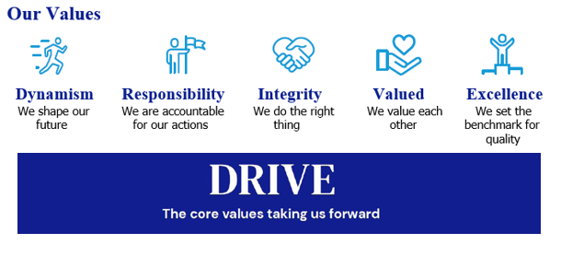

Our Culture
We are ambitious in working together to promote a more inclusive environment, which attracts all candidates and signals our commitment to celebrate and promote diversity. Idox is a company where we can all be ourselves and succeed on merit, where we respect all our employees, customers, and communities in which we live, work and are a part of.
We recruit and reward employees based on capability and performance – regardless of race, gender, sexual orientation, gender identity or expression, lifestyle, age, educational background, national origin, religion or physical ability. Each office location worldwide, is free to respond to local needs to create a culturally sensitive workplace for everyone. In doing so, we want every employee to feel our commitment to showing respect for all and encouraging open collaboration and communication.


Our Benefits

Flex to Fit
We recognise that for individuals, the opportunity to work flexibly can enable them to achieve a better work-life balance along with a greater sense of responsibility, ownership, and control of their working life. During the pandemic, all our employees successfully transitioned to remote working, and we are open to conversations on work patterns to suit our employees needs such as change to working times; part time working; term time working; 9-day fortnight. We are proud to be a flexible employer enabling effective hybrid working for our employees.

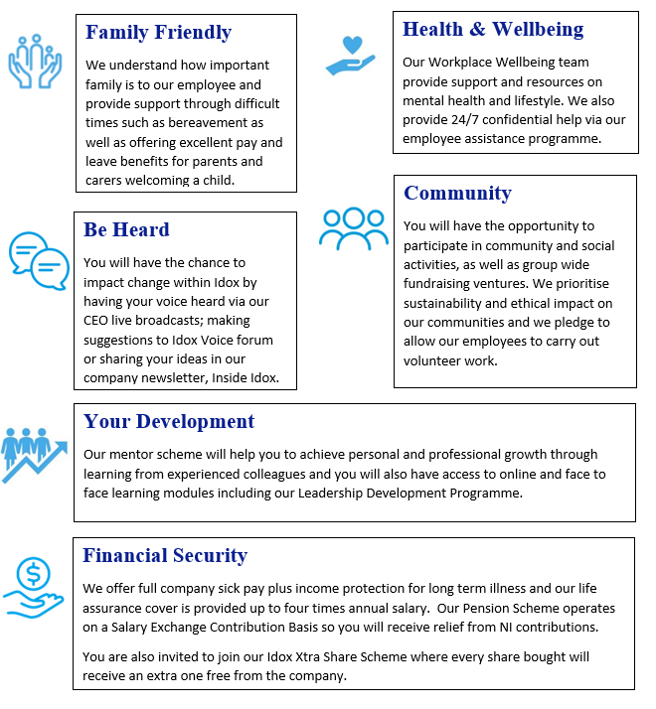

How to apply
Please submit a CV, and a short cover letter (maximum 500 words - including salary expectation, and current remuneration) explaining why you feel you would be suited to this role to join.us@idoxgroup.com
Please note successful applicants will need to satisfy the BPSS guidelines (Baseline Personnel Security Standards) which consist of the receipt of satisfactory references covering the last 3 years of employment; an identity check; verification of eligibility to work in the UK; and a Basic Disclosure Check. This is to help us make safer recruitment decisions.

Privacy notice
As part of the recruitment process, we will collect data about you in a variety of ways including the information you would normally include in a CV or a job application cover letter, or notes made by our recruiting officers during a recruitment interview.

Please read our Recruitment Data Privacy Policy here: https://www.idoxgroup.com/policies

