Salesforce Lead

Pune, Maharashtra - India

Key responsabilités :
- Ensure the support inbox is covered for the FinancialForce Profession Services Automation (PSA) environment.
- Ensure the support inbox is covered for the Salesforce Sales Cloud environment.
- Regularly reviews system configuration for efficiencies (streamlining workflows, eliminating unnecessary custom fields, archiving, or purging old data, etc.).
- Monitoring inbox including work based on the needs of different users. Collaborate with end users to understand administrative needs, resolve issues, and meet business requirements.
- Handle all administrative functions including reports and dashboards, validations, custom objects, permission sets, approval workflows, email templates.
- Maintaining, enhancing, and creating flows
- Assist in training of new PSA users / Salesforce Users
- Resolve data quality issues and manage data imports.
- Creating and maintaining FinancialForce/Salesforce documentation for end users
- Play an important part in helping advance and support our Salesforce practices, alongside managing our environments and release process, including sandbox usage planning, metadata and data migration, environments comparisons and version control.
- Recommending & supporting apps and third-party products that can be used to enhance Salesforce/PSA
Support the administration of Salesforce Sales Cloud, Pardot (marketing automation tool), Deal Hub (CPQ tool) & Clari (Rev Ops tool)

Required Skills :
- 5 +years’ experience with Salesforce (Lightning) Sales Cloud
- Configuration skill set (workflows, validation rules, approval processes)
- 2+ years’ experience in flows
- Experience in using data loader.
- Strong knowledge of Excel and proficient in other MS office tools
- Minimum Advanced Admin certification
- Experienced in leading a team.
- Excellent written and spoken skills.
- Experience in supporting users, supporting tickets user queries, user training etc.
Good to have:
- Pardot experience
Nice to have:
- FinancialForce PSA knowledge
- Clari experience

About Idox
Our specialist software solutions power the performance of government and industry, driving productivity and a better experience for everyone. Built around the user and designed in collaboration with experts who have worked through every detail of every process from end-to-end, our hard-working process engines deliver exceptional functionality and embed workflows that drive efficiency and best practice with a long-term focus for regulated environments.
Through the automation of tasks, the simplification of complex operations, finding scalability as operations evolve, and more effective management of information, we help our customers harness the power of Digital, so they can do more.
We employ around 500 staff in the UK and worldwide, including Europe, North America and Asia, so some travel to meet colleagues may be required.

Our Values 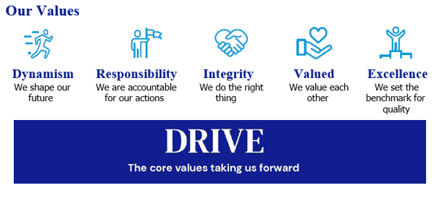

Our Culture
We are ambitious in working together to promote a more inclusive environment, which attracts all candidates and signals our commitment to celebrate and promote diversity. Idox is a company where we can all be ourselves and succeed on merit, where we respect all our employees, customers, and communities in which we live, work and are a part of.
We recruit and reward employees based on capability and performance – regardless of race, gender, sexual orientation, gender identity or expression, lifestyle, age, educational background, national origin, religion, or physical ability. Each office location worldwide, is free to respond to local needs to create a culturally sensitive workplace for everyone. In doing so, we want every employee to feel our commitment to showing respect for all and encouraging open collaboration and communication.


Our Benefits

Flex to Fit
We recognise that for individuals, the opportunity to work flexibly can enable them to achieve a better work-life balance along with a greater sense of responsibility, ownership and control of their working life. During the pandemic, all our employees successfully transitioned to remote working and we are open to conversations on work patterns to suit our employees needs such as change to working times; part time working; term time working; 9-day fortnight. We are proud to be a flexible employer enabling effective hybrid working for our employees.

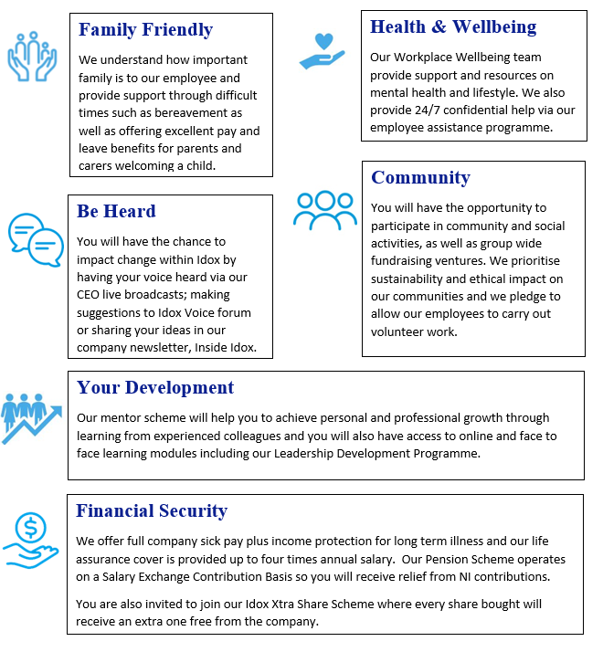

How to Apply
Please submit a CV, and a short cover letter (maximum 500 words - including salary expectation, and current remuneration) explaining why you feel you would be suited to this role to join.us@idoxgroup.com
Please note successful applicants will need to satisfy the BPSS guidelines (Baseline Personnel Security Standards) which consist of the receipt of satisfactory references covering the last 3 years of employment; an identity check; verification of eligibility to work in the UK; and a Basic Disclosure
Check. This is in order to help us make safer recruitment decisions.

Privacy notice
As part of the recruitment process, we will collect data about you in a variety of ways including the information you would normally include in a CV or a job application cover letter, or notes made by our recruiting officers during a recruitment interview.

Please read our Recruitment Data Privacy Policy here: https://www.idoxgroup.com/policies

