Front End Developer

Idox Software

Pune or Home Based

About the role
This is an exciting opportunity for an experienced front end software developer to join the thinkWhere geospatial team at Idox Software Limited.
Our software team are at the leading edge of cloud delivery for web mapping and pioneering geographic information systems (GIS). Using globally leading open-source technologies, this is a team which is passionate about applying mapping and geographic data to improve and innovate what our customers do.
As a Front End Developer you will play an essential role in the design, development and deployment of pioneering software products and customer solutions that drive new ways of working across many market sectors.
You will be joining a highly experienced software development team to work on our modern cloud platforms and leading web GIS software applications.
Working with leading technologies you will be responsible for designing and improving the user experience of our core web products and project solutions.
If you have experience with front end development and excellent programming skills, we would really like to meet you.
Idox is a company with strong ambition. There is great career potential for those who show initiative and an aptitude for leadership. You will have a buddy from day one, to make sure you can make the most of learning opportunities in the business. We offer a comprehensive benefits package and flexible working to support your wellbeing as well as your professional development.

Key responsibilities
- Take a leadership role in designing, developing, and maintaining high-quality front-end web-based solutions, with a focus on visual design and optimal user experience.
- Collaborate closely with other developers, test engineers and product owners to deliver data-driven web applications.
- Create wireframes, prototypes and high-fidelity mock-ups in line with user requirements.
- Conduct user research and testing to ensure designs meet the needs and expectations of users.
- Translate design concepts and wireframes into functional, responsive and scalable code using HTML, CSS and JavaScript frameworks.
- Contribute to product planning and roadmap development.
- Engage with colleagues to refine and estimate packages of work.
- Own complex tasks and deliver them to meet commercial and quality objectives.
- Monitor and report progress on assigned work, identifying, controlling and reporting on risks.
- Conduct code reviews and provide constructive feedback to colleagues, fostering a culture of continuous improvement and adherence to best practices.
- Provide mentoring and support for less experienced colleagues.
- Stay up to date with the latest industry trends, emerging technologies, and best practices in front-end development, sharing knowledge and driving innovation within the team.

To be successful, you’ll need to bring :
- 3+ years development experience with the following technologies:
  - Angular, Bootstrap, CSS, TypeScript, nodeJS.
- Practical experience using design and prototyping tools e.g. Adobe XD, Figma
- Proven experience of producing clean, maintainable, and extensible code​.
- Experience with building and deploying distributed web applications.
- Strong understanding of good software design principles.
- Excellent problem solving and analytical skills.
- Passion for technology and ability to generate new ideas and solutions.
- Excellent written and verbal communication skills.
- Ability to work well with others in multi-functional teams.
- Strong visual design skills.

Additional desirable qualities:
- Degree in software engineering, computer studies or related discipline.
- Familiarity with digital mapping and geospatial data

About Idox
Our specialist software solutions power the performance of government and industry, driving productivity and a better experience for everyone. Built around the user and designed in collaboration with experts who have worked through every detail of every process from end-to-end, our hard-working process engines deliver exceptional functionality and embed workflows that drive efficiency and best practice with a long-term focus for regulated environments.
Through the automation of tasks, the simplification of complex operations, finding scalability as operations evolve, and more effective management of information, we help our customers harness the power of Digital, so they can do more.
We employ around 500 staff in the UK and worldwide, including Europe, North America and Asia, so some travel to meet colleagues may be required.

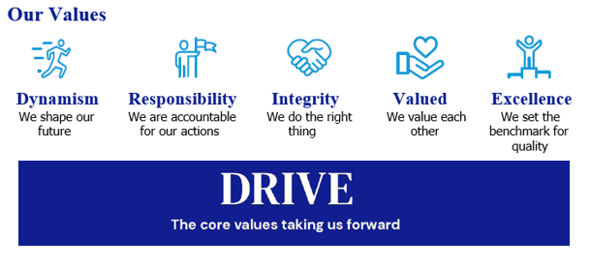
Our Values

Our Culture
We are ambitious in working together to promote a more inclusive environment, which attracts all candidates and signals our commitment to celebrate and promote diversity. Idox is a company where we can all be ourselves and succeed on merit, where we respect all our employees, customers and communities in which we live, work and are a part of.
We recruit and reward employees based on capability and performance – regardless of race, gender, sexual orientation, gender identity or expression, lifestyle, age, educational background, national origin, religion or physical ability. Each office location worldwide, is free to respond to local needs to create a culturally sensitive workplace for everyone. In doing so, we want every employee to feel our commitment to showing respect for all and encouraging open collaboration and communication.

Our Benefits

Flex to Fit
We recognise that for individuals, the opportunity to work flexibly can enable them to achieve a better work-life balance along with a greater sense of responsibility, ownership and control of their working life. During the pandemic, all our employees successfully transitioned to remote working and we are open to conversations on work patterns to suit our employees needs such as change to working times; part time working; term time working; 9-day fortnight. We are proud to be a flexible employer enabling effective hybrid working for our employees.

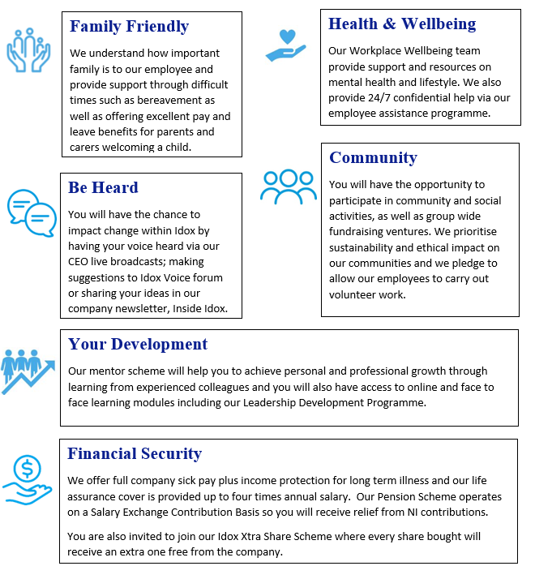

How to apply
Please submit a CV, and a short cover letter (maximum 500 words - including salary expectation, and current remuneration) explaining why you feel you would be suited to this role to join.us@idoxgroup.com
Please note successful applicants will need to satisfy the BPSS guidelines (Baseline Personnel Security Standards) which consist of the receipt of satisfactory references covering the last 3 years of employment; an identity check; verification of eligibility to work in the UK; and a Basic Disclosure Check. This is in order to help us make safer recruitment decisions.

Privacy notice
As part of the recruitment process, we will collect data about you in a variety of ways including the information you would normally include in a CV or a job application cover letter, or notes made by our recruiting officers during a recruitment interview.

Please read our Recruitment Data Privacy Policy here: https://www.idoxgroup.com/policies

