Cloud DevOps Engineer

Idox Software

Pune or Home Based

About the role
This is an exciting opportunity for an experienced Cloud DevOps Engineer to join the thinkWhere geospatial team at Idox Software Limited.
Our software team are at the leading edge of cloud delivery for web mapping and pioneering geographic information systems (GIS). Using globally leading open-source technologies, this is a team which is passionate about applying mapping and geographic data to improve and innovate what our customers do.
As a Cloud DevOps Engineer you will play an essential role in the design, development and deployment of pioneering software products and customer solutions that drive new ways of working across many market sectors.
You will be joining a highly experienced software development team to work on our modern cloud platforms and leading web GIS software applications.
Working with leading technologies you will be responsible for maintaining and improving our cloud infrastructure, improving our CI/CD processes, process automation, configuration management and enhancing our infrastructure security protocols.
Idox is a company with strong ambition. There is great career potential for those who show initiative and an aptitude for leadership. You will have a buddy from day one, to make sure you can make the most of learning opportunities in the business. We offer a comprehensive benefits package and flexible working to support your wellbeing as well as your professional development.

Key responsibilities
- Deployment, automation, management, and maintenance of AWS cloud-based production system.
- Ensuring availability, performance, security, and scalability of AWS production systems.
- Management of creation, release, and configuration of production systems.
- Evaluation of new technology within the AWS environment.
- System troubleshooting and problem resolution across various application domains and platforms.
- Provision of critical system security by leveraging best practices
- Providing recommendations for architecture and process improvements.
- Incidence management and root cause analysis
- Definition and deployment of systems for metrics, logging, and monitoring on AWS platform.
- Optimise performance and usage of cloud based services
- Improve automation of infrastructure management and the deployment process
- Stay up to date with the latest DeOps trends, emerging technologies, and best practices, sharing knowledge and driving innovation within the team.

To be successful, you’ll need to bring :
- 3+ years experience with the following AWS services:
  - EC2, EFS, S3, RDS, VPC, IAM, CloudFront, CloudWatch, SQS, ElasticBeanstalk, Lambda, Route53
- Proven experience with multi-tier architectures: load balancers, caching, web servers, application servers, databases, and networking.
- Proven experience using Infrastructure as Code, including Terraform, Packer, Ansible
- Proven experience of creating and deploying Docker containers within Linux
- Experience with deploying distributed web applications
- Strong understanding of how to secure AWS environments and meet compliance requirements.
- Excellent problem solving and analytical skills.
- Passion for technology and ability to generate new ideas and solutions.
- Excellent written and verbal communication skills.
- Ability to work well with others in multi-functional teams.

Additional desirable qualities:
- AWS certification highly desirable
- Experience in AWS Disaster Recovery design
- Experience of working with Agile SCRUM methods of project delivery and iterative software development.
- Degree in software engineering, computer studies or related discipline.

About Idox
Our specialist software solutions power the performance of government and industry, driving productivity and a better experience for everyone. Built around the user and designed in collaboration with experts who have worked through every detail of every process from end-to-end, our hard-working process engines deliver exceptional functionality and embed workflows that drive efficiency and best practice with a long-term focus for regulated environments.
Through the automation of tasks, the simplification of complex operations, finding scalability as operations evolve, and more effective management of information, we help our customers harness the power of Digital, so they can do more.
We employ around 500 staff in the UK and worldwide, including Europe, North America and Asia, so some travel to meet colleagues may be required.

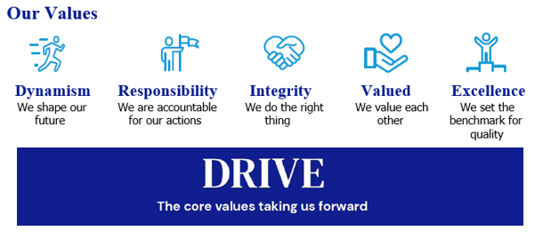
Our Values

Our Culture
We are ambitious in working together to promote a more inclusive environment, which attracts all candidates and signals our commitment to celebrate and promote diversity. Idox is a company where we can all be ourselves and succeed on merit, where we respect all our employees, customers and communities in which we live, work and are a part of.
We recruit and reward employees based on capability and performance – regardless of race, gender, sexual orientation, gender identity or expression, lifestyle, age, educational background, national origin, religion or physical ability. Each office location worldwide, is free to respond to local needs to create a culturally sensitive workplace for everyone. In doing so, we want every employee to feel our commitment to showing respect for all and encouraging open collaboration and communication.


Our Benefits

Flex to Fit
We recognise that for individuals, the opportunity to work flexibly can enable them to achieve a better work-life balance along with a greater sense of responsibility, ownership and control of their working life. During the pandemic, all our employees successfully transitioned to remote working and we are open to conversations on work patterns to suit our employees needs such as change to working times; part time working; term time working; 9-day fortnight. We are proud to be a flexible employer enabling effective hybrid working for our employees.

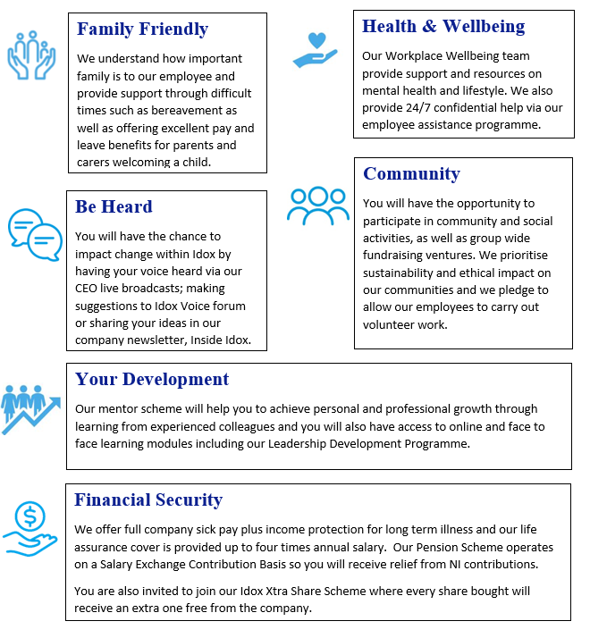

How to apply
Please submit a CV, and a short cover letter (maximum 500 words - including salary expectation, and current remuneration) explaining why you feel you would be suited to this role to join.us@idoxgroup.com
Please note successful applicants will need to satisfy the BPSS guidelines (Baseline Personnel Security Standards) which consist of the receipt of satisfactory references covering the last 3 years of employment; an identity check; verification of eligibility to work in the UK; and a Basic Disclosure Check. This is in order to help us make safer recruitment decisions.

Privacy notice
As part of the recruitment process, we will collect data about you in a variety of ways including the information you would normally include in a CV or a job application cover letter, or notes made by our recruiting officers during a recruitment interview.

Please read our Recruitment Data Privacy Policy here: https://www.idoxgroup.com/policies

